TABLE OF CONTENTS

CANDIDATE’S DECLARATION i

CERTIFICATE ii

ACKNOWLEDMENT iii
TABLE OF CONTENTS vi-vii
CHAPTER 1: INTRODUCTION 1-3
1.1 What is Library Management System ? 1
1.2 Objective
1.3 Features of Library Management System 2
CHAPTER 2: INTRODUCTION TO PYTHON 4-6
2.1 What is Python? 4
2.2 Brief history of Python 4
2.3 GUI programming using Python 5
CHAPTER 3: PYTHON TKINTER 7-24
3.1 Introduction 7-16
3.2 Advantages of Tkinter 17-24
CHAPTER 4: DATABASE MANAGEMENT SYSTEM 25-35
4.1 What is DBMS 25
4.2 Advantages of DBMS 25
4.3 Relational Database Management System 26
CHAPTER 5: MySQL 36-43
5.1 Introduction to MySQL 40
5.2 Advantages of MySQL 42
CHAPTER 6: SNAPSHOTS OF PROJECT 44-44
CHAPTER 7: CONCLUSION AND FUTURE WORK
REFERENCES 45-49

CHAPTER 1: INTRODUCTION

CHAPTER 1.1: WHAT IS LIBRARY MANAGEMENT SYSTEM?

The Library Management System is a data processing to perform routine Library activities. This system is concerned with developing a library management system using database software. In this system the library management becomes more efficient and easier to handle with its reliable system components. Library system was developed in order to make computerized the borrowing and returning of books, adding books, deleting books and viewing books.

A Library Management System, also known as automated library management system is software that has been developed the basic housekeeping functions of a library. Libray automation is the general term for information and communications technologies(ICT) that are used to replace manual systems in the library.


The functions that may be automated are any or all of the following acquisition, catalogging, circulation, serials management and reference. When the library management system is integrated to make the existing system more efficient to provide a user-friendly environment where the user can be serviced better, make functioning of library faster, provide a system where the library staff can catch defaulters and not let them escape.

CHAPTER 1.2: OBJECTIVE

The objective of this application is to design a system to maintain the information related to a Library Management. The purpose is to maintain a centralized repository of information about all activities regarding a Library.

Goals of the Project:
- To reduce paperwork
- High performance
- Retrieve information in minimum time
- More user friendly
- Reduce work overload
- Highly secure

CHAPTER 1.3: FEATURES OF LIBRARY MANAGEMENT SYSTEM

- Adding details of the book
- Deleting book details
- Viewing all the books
- Issuing book to students
- Returning book

CHAPTER 2: INTRODUCTION TO PYTHON

CHAPTER 2.1: WHAT IS PYTHON?

Python is a high-level, general-purpose programming language. Its design philosophy emphasizes code readability with the use of significant indentation.
Python is dynamically-typed and garbage-collected. It supports multiple programming paradigms, including structured (particularly procedural), object-oriented and functional programming. It is often described as a "batteries included" language due to its comprehensive standard library.

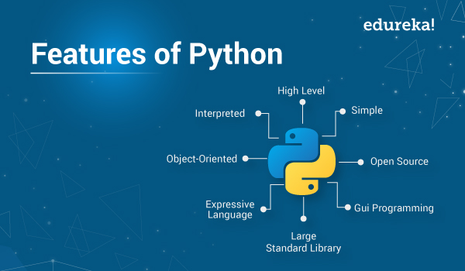

CHAPTER 2.2: BRIEF HISTORY OF PYTHON

Guido van Rossum began working on Python in the late 1980s as a successor to the ABC programming language and first released it in 1991 as Python 0.9.0.[35] Python 2.0 was released in 2000 and introduced new features such as list comprehensions, cycle-detecting garbage collection, reference counting, and Unicode support. Python 3.0, released in 2008, was a major revision that is not completely backward-compatible with earlier versions. Python 2 was discontinued with version 2.7.18 in 2020.

CHAPTER 2.3: GUI PROGRAMMING USING PYTHON

A graphical interface, or GUI, is an interactive environment that is the first thing a user sees and interacts with altering opening an application or website. A system of interactive visual components for computer software, a GUI displays objects that convey information, and it represents actions that a user can take. The objects can change color, size, or visibility when the user interacts with them. A GUI can include graphical elements like icons, cursors, and buttons that can also be enhanced with sounds or visual effects, such as transparency.
A good GUI is crucial for increasing your platform’s reputation and user count, and the combination of all of these elements plays a big role in your application or website’s user experience.
When creating GUIs, many developers turn to Python, which has a lot of different frameworks. Python is an interactive programming language that makes it easy to get started with programming a GUI framework. Python has a wide range of options for GUI frameworks, including Cross-Platform frameworks and Platform-Specific frameworks.
The 10 best Python libraries for GUI programming are:
- PyQt5
- Tkinter
- Kivy
- wxPython
- PySimpleGUI
- Libavg
- PyForms
- PySide2
- Wax
- PyGUI

In the successful completion of this project, we use Tkinter library.

CHAPTER 3: PYTHON TKINTER

CHAPTER 3.1: INTRODUCTION

Another top Python library for GUI is Tkinter, which is an open-source Python Graphic User Interface library. It is well known for its simplicity and comes pre-installed in Python, meaning there is no work on your part. These features make it a great choice for beginners and intermediates, but it is not capable of carrying out larger-scale projects.
With Tkinter, the visual elements are called widgets, and each of the widgets comes with a different level of customizability. It also offers a wide range of commonly used elements that many developers are already familiar with, such as Frame, Buttons, Checkbuttons, Labels, File Dialogs, and Canvas.

CHAPTER 3.2: ADVANTAGES OF TKINTER

Here are some of the main advantages of Tkinter:
- Easy-to-use and fast to implement
- Flexible and stable
- Included in Python
- Provides a simple syntax

CHAPTER 4: DATABASE MANAGEMENT SYSTEM

CHAPTER 4.1: WHAT IS DBMS?

A database management system (or DBMS) is essentially nothing more than a computerized data-keeping system. Users of the system are given facilities to perform several kinds of operations on such a system for either manipulation of the data in the database or the management of the database structure itself. Database Management Systems (DBMSs) are categorized according to their data structures or types.

CHAPTER 4.2: ADVANTAGES OF DBMS

- Controls database redundancy: It can control data redundancy because it stores all the data in one single database file and that recorded data is placed in the database.
- Data sharing: In DBMS, the authorized users of an organization can share the data among multiple users.
- Easily Maintenance: It can be easily maintainable due to the centralized nature of the database system.
- Reduce time: It reduces development time and maintenance need.
- Backup: It provides backup and recovery subsystems which create automatic backup of data from hardware and software failures and restores the data if required.
- multiple user interface: It provides different types of user interfaces like graphical user interfaces.
CHAPTER 4.3: RELATIONAL DATABASE MANAGEMENT SOFTWARE
RDBMS stands for Relational Database Management System. All modern database management systems like SQL, MS SQL Server, IBM DB2, ORACLE, My-SQL, and Microsoft Access are based on RDBMS. It is called Relational Database Management System (RDBMS) because it is based on the relational model introduced by E.F. Codd.
Example: MySQL, Oracle Database, PostgreSQL etc

CHAPTER 5: MySQL

CHAPTER 5.1: INTRODUCTION TO MySQL
MySQL is an open-source relational database management system (RDBMS). Its name is a combination of "My", the name of co-founder Michael Widenius's daughter My, and "SQL", the acronym for Structured Query Language. A relational database organizes data into one or more data tables in which data may be related to each other; these relations help structure the data. SQL is a language programmers use to create, modify and extract data from the relational database, as well as control user access to the database. In addition to relational databases and SQL, an RDBMS like MySQL works with an operating system to implement a relational database in a computer's storage system, manages users, allows for network access and facilitates testing database integrity and creation of backups.
CHAPTER 5.2: ADVANTAGES OF MySQL
MySQL is a free-to-use, open-source database that facilitates effective management of databases by connecting them to the software. It is a stable, reliable and powerful solution with advanced features like the following:
- Data security
- On-Demand Scalability
- High Performance
- Round-the-clock Uptime
- Comprehensive Transactional Support
- Complete Workflow Support
- Reduced total cost of ownership
- The flexibility of open source

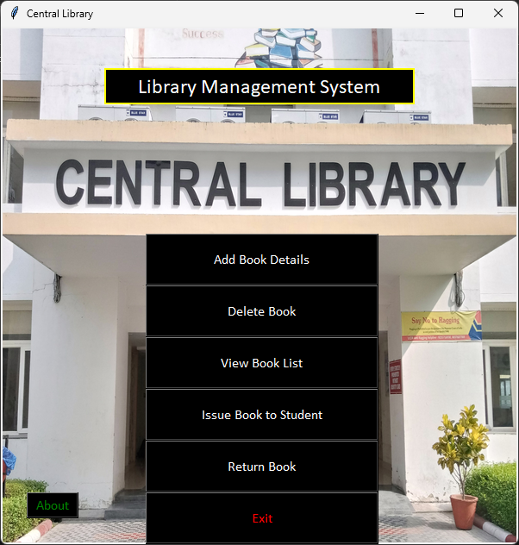
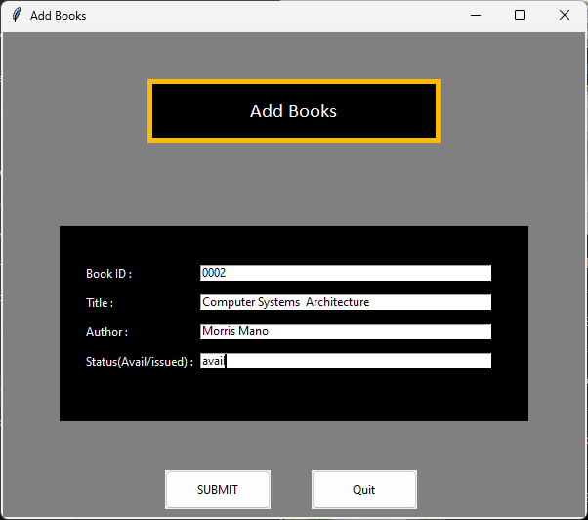
CHAPTER 6: SNAPSHOTS OF PROJECT

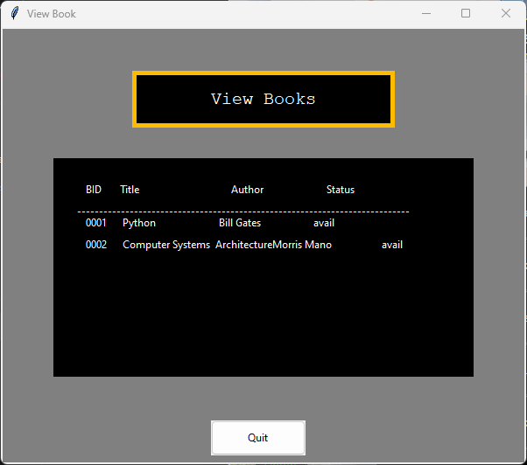
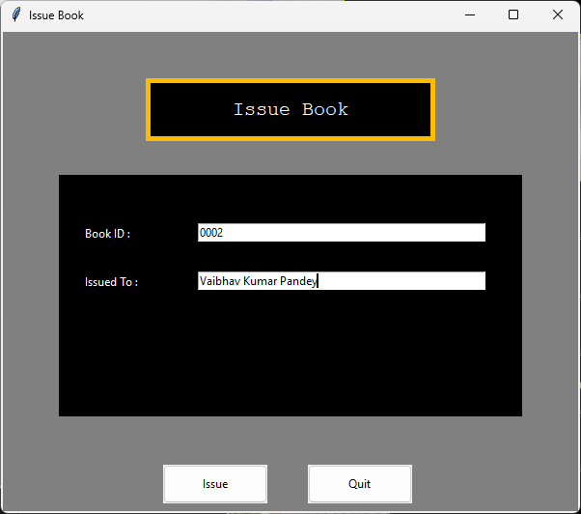

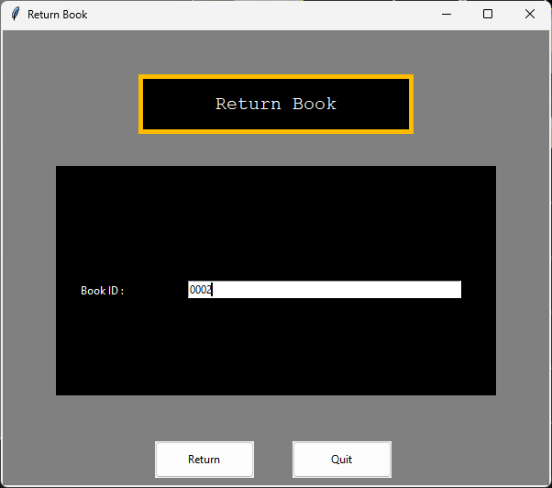
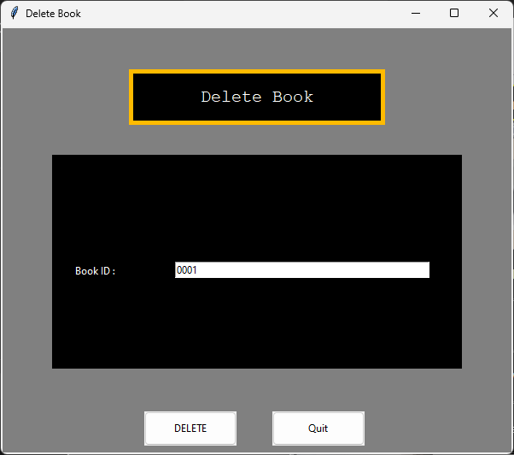

CHAPTER 7: CONCLUSION AND FUTURE WORK

Using this Library Management System, workforce required to manage books is reduced and time consumed in managing records also reduced. Using this software, keeping and managing records of availability of books is also optimized. Also, this software is very user friendly and easy to use. With MySQL, all the records are secure and cannot be manipulated.
Many more features are to be added in this project as per the costumer demands.

CHAPTER 6: REFERENCES

- Summer Internship Training
- Google
- Wikipedia
- Tutorialspoint
- Datamation.com
- Python Official Documentary
- Javatpoint

